PATTERN BASED QUESTIONS

- Right-Angled Triangle of Stars
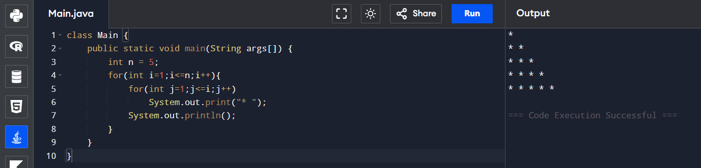

- Number Pyramid
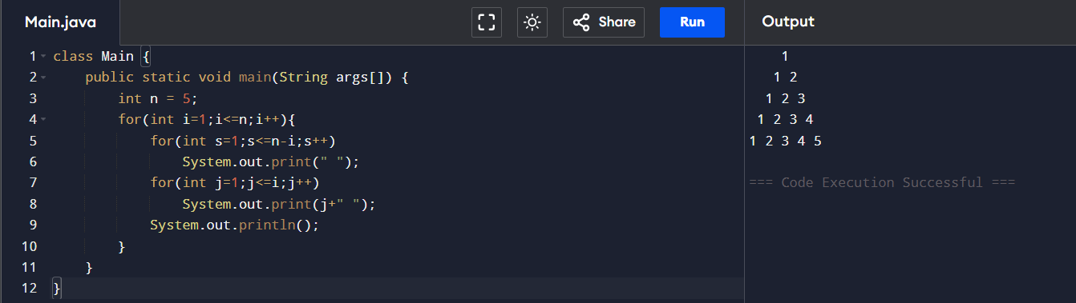

- Hollow Square Pattern
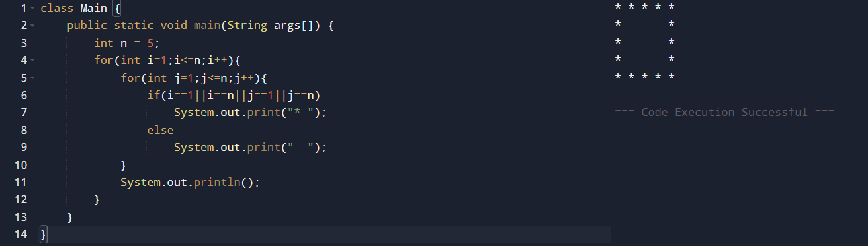

- Number Right-Angled Triangle
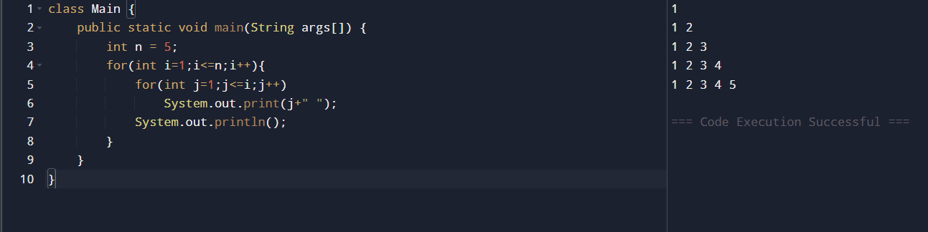

- Alphabet Triangle Pattern
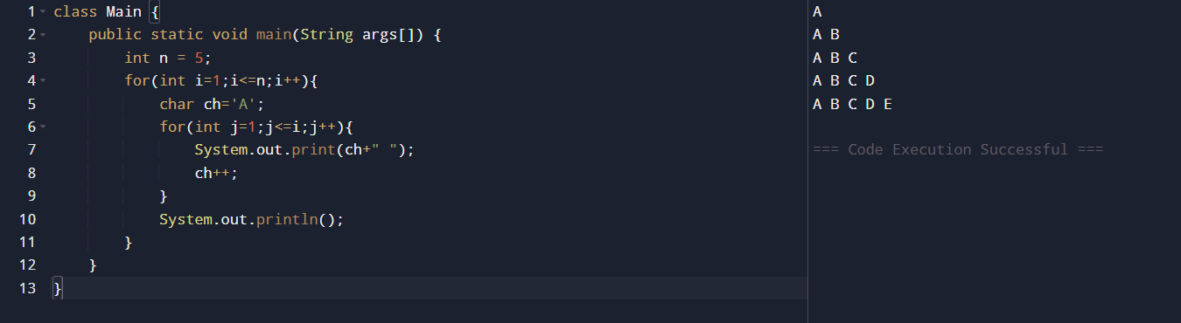

- Diamond Star Pattern
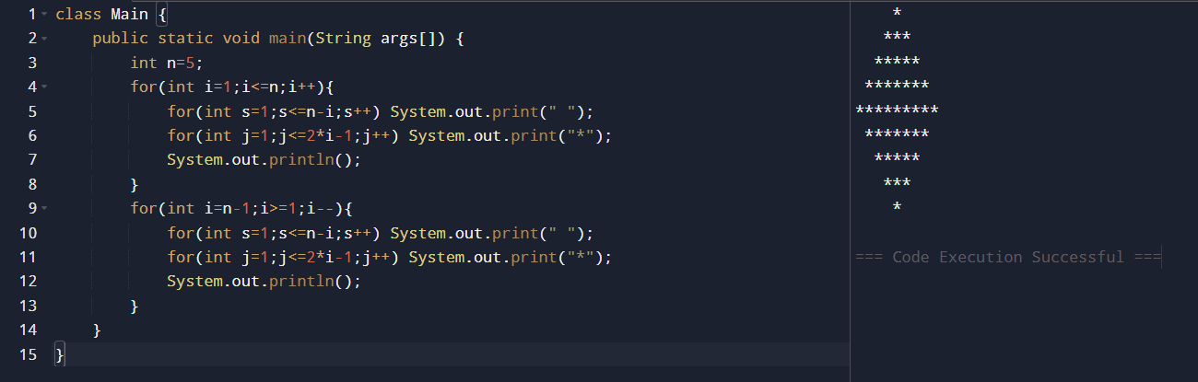

- Floyd’s Triangle
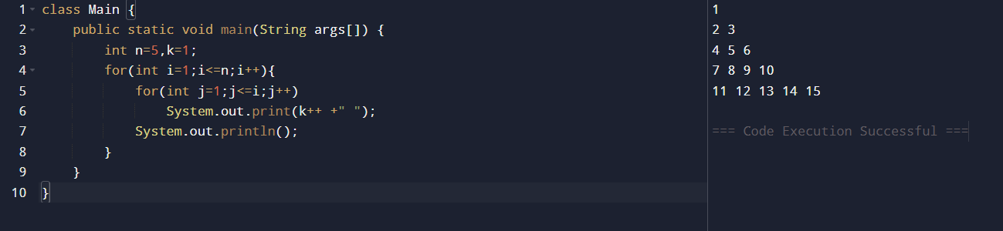

- Right-Aligned Star Triangle
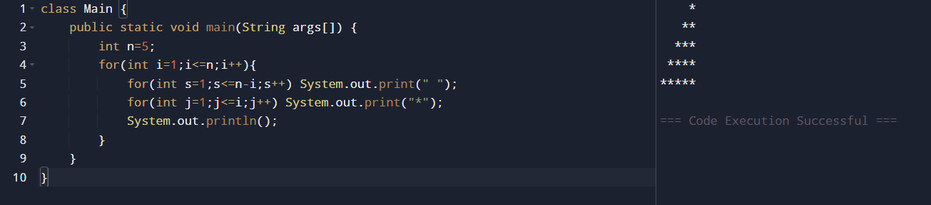

- Inverted Number Triangle
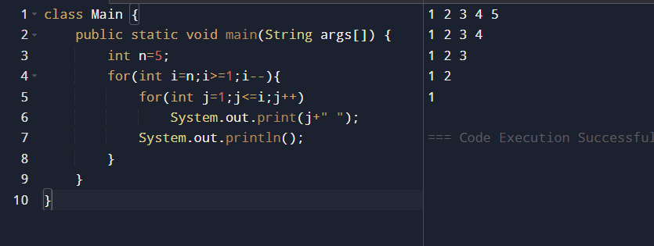

- Binary Number Triangle
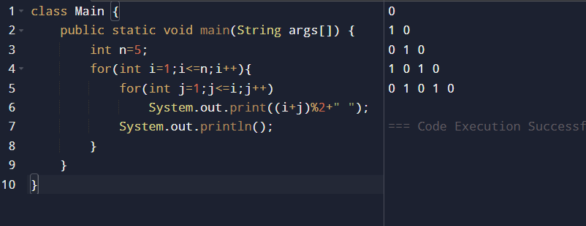

- Hollow Right-Angled Triangle
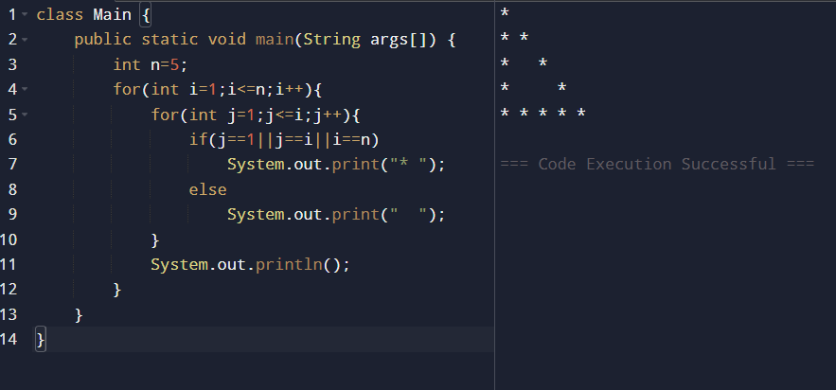

- Reverse Pyramid of Stars
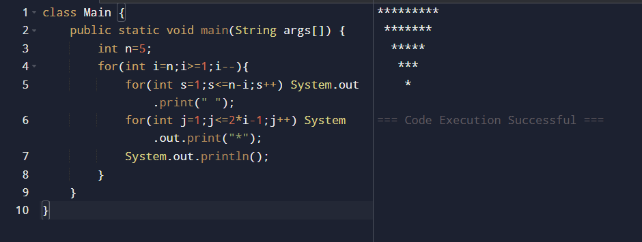

- Continuous Characters Triangle
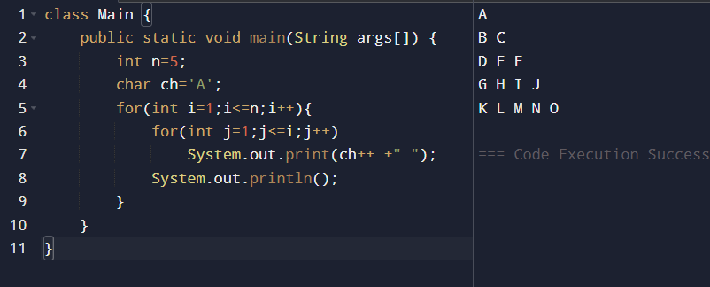

- Right-Angled Triangle with Even Numbers
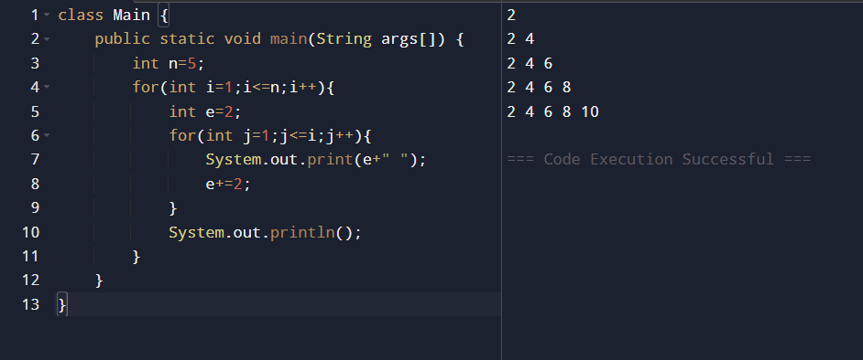

- Triangle of Odd Numbers
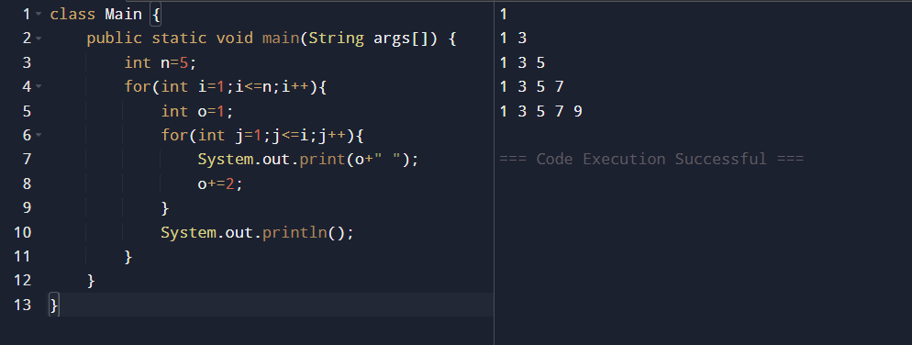
- Hollow Pyramid Pattern
